AI TOOLS NOTES
Unit Topic:
“AI Data Studio — Smart Automation Studio”
Prepared for: Undergraduate 2nd Year Students
Subject Area: AI Tools & Applications
Format: Theory Notes with Diagrams

1. Introduction
A ‘Smart Automation Studio’ is a modern workspace — usually cloud-based — where raw data from many sources is collected, cleaned, analysed with the help of Artificial Intelligence, and then acted upon automatically, with little or no manual intervention. It combines three ideas that used to be separate: data analytics, workflow automation, and AI decision-making, into one connected system.
For students, understanding an AI Data Studio is important because almost every modern organisation — from a small start-up to a large bank — now runs some version of this pipeline to reduce manual work, spot patterns faster, and respond to events in real time. This unit introduces the theory behind such studios and the popular tools used to build them.
- Definition: An AI Data Studio (or Smart Automation Studio) is an integrated environment that automates the full cycle of data collection, processing, AI-based analysis, and action-triggering, usually through no-code or low-code tools.

2. Core Architecture of an AI Data Studio
Every automation studio, regardless of the specific tools used, follows the same underlying architecture: data flows in from multiple sources, is processed centrally (often with AI assistance), and flows out as either human-readable insight or machine-triggered action.
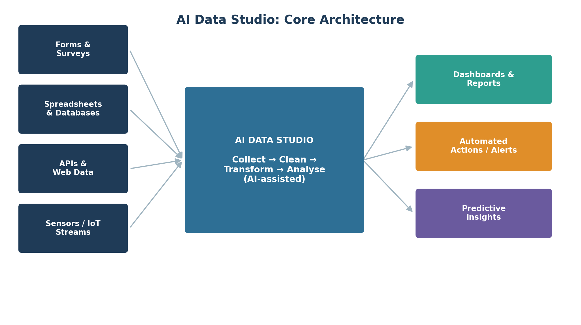
Figure 1: Core architecture of an AI Data Studio — sources, central processing, and outputs.

2.1 The Three Layers
- Input Layer (Data Sources): Forms, spreadsheets, databases, APIs, and IoT sensors feed raw data into the system continuously or on a schedule.
- Processing Layer (The Studio): Data is cleaned (removing duplicates/errors), transformed (reshaping, merging), and analysed using AI models (classification, prediction, anomaly detection).
- Output Layer (Action & Insight): Results appear as dashboards for humans, or trigger automated actions such as alerts, emails, or updates to other systems — with no manual step required.

3. The Smart Automation Studio Toolkit
No single tool does everything. A real-world automation studio is usually assembled from several specialised categories of tools working together. The map below groups the most widely used tools by category.
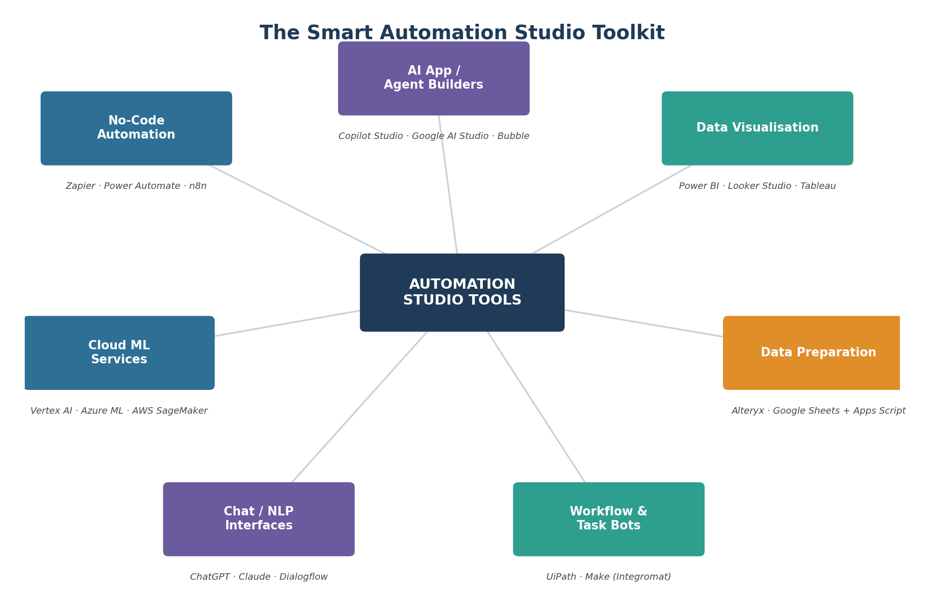
Figure 2: Categories of tools that together make up a Smart Automation Studio.

3.1 Category Details
Category | Purpose | Example Tools
No-Code Automation | Connects apps & triggers actions without coding | Zapier, Power Automate, n8n
AI App / Agent Builders | Build custom AI assistants or mini-apps | Copilot Studio, Google AI Studio, Bubble
Data Visualisation | Turns processed data into dashboards | Power BI, Looker Studio, Tableau
Data Preparation | Cleans and reshapes raw data before analysis | Alteryx, Google Sheets + Apps Script
Workflow & Task Bots | Automates repetitive, rule-based desktop tasks | UiPath, Make (Integromat)
Chat / NLP Interfaces | Adds a conversational layer for querying data | ChatGPT, Claude, Dialogflow
Cloud ML Services | Hosts & trains custom machine-learning models | Vertex AI, Azure ML, AWS SageMaker

4. The Smart Automation Workflow
Regardless of which tools are used, a smart automation process follows a repeatable six-step workflow. Understanding this cycle theoretically helps you design any automation, even with a new or unfamiliar tool.
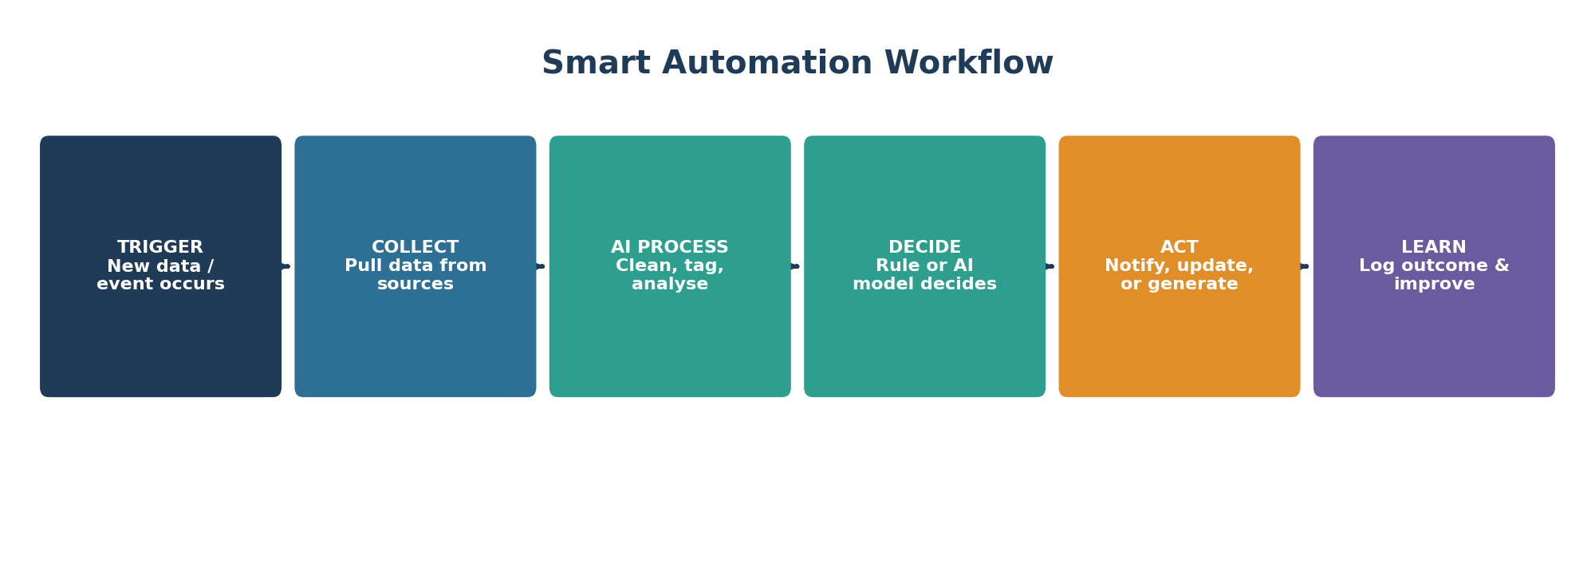
Figure 3: The six-stage Smart Automation Workflow cycle.
- 1. Trigger: An event starts the process — a new form submission, a file upload, or a scheduled time.
- 2. Collect: The studio pulls the relevant data from one or more connected sources.
- 3. AI Process: Data is cleaned, tagged, categorised, or scored using an AI/ML model.
- 4. Decide: A rule engine or AI model decides what should happen next, based on the processed data.
- 5. Act: The system performs the action automatically — sending a notification, updating a record, or generating a report.
- 6. Learn: The outcome is logged, allowing the workflow (or the underlying AI model) to be refined over time.

5. A Simple Classroom Case Study
Imagine a college wants to automatically sort and respond to student feedback forms. Using an AI Data Studio approach: a Google Form (trigger) collects responses, the data lands in a spreadsheet (collect), an AI sentiment-analysis model tags each response as positive, neutral, or negative (AI process), a rule checks for any ‘negative’ tag (decide), and if found, an automated email is sent to the department coordinator (act) while all results populate a live dashboard for the term (learn/insight).
This entire pipeline can be built by a second-year student using only no-code tools — for example, Google Forms + Google Sheets + a simple AI API call through Apps Script + a Looker Studio dashboard — without writing a full backend application.

6. Benefits and Limitations

6.1 Benefits
- Saves significant manual effort on repetitive data tasks.
- Reduces human error in data entry and routing.
- Provides faster, near real-time insight compared to manual reporting.
- Most tools are no-code or low-code, making them accessible to non-programmers.

6.2 Limitations
- Over-reliance on automation can hide errors if the AI model is poorly trained or biased.
- Many tools charge per task/run, so costs can grow quickly at scale.
- Sensitive data flowing through third-party cloud tools raises privacy and compliance concerns.
- Automated decisions still need periodic human review, especially for high-impact actions.

7. Getting Started: A Learning Path
- Step 1: Start with a single no-code automation tool (e.g., Zapier or Power Automate) and connect two simple apps.
- Step 2: Learn basic data cleaning in Google Sheets or Excel before introducing any AI step.
- Step 3: Add one AI capability — such as a sentiment classifier or an image-tagging API — to an existing simple workflow.
- Step 4: Visualise the results using a free dashboard tool such as Looker Studio.
- Step 5: Document the full pipeline (trigger → action) and add it to your AI portfolio as a mini-project.

8. Conclusion
An AI Data Studio, or Smart Automation Studio, is not one product but a way of thinking about data: as something that should flow automatically from source to insight to action, with AI assisting at the processing stage. Learning this pattern — rather than memorising any single tool — prepares you to adapt quickly as new automation platforms continue to emerge.
Start small: automate one real, repetitive task in your own college or personal life, and you will already understand this unit better than any textbook definition alone can teach.

9. Quick Reference: Tool Comparison
Category | Purpose | Example Tools
No-Code Automation | Connects apps & triggers actions without coding | Zapier, Power Automate, n8n
AI App / Agent Builders | Build custom AI assistants or mini-apps | Copilot Studio, Google AI Studio, Bubble
Data Visualisation | Turns processed data into dashboards | Power BI, Looker Studio, Tableau
Data Preparation | Cleans and reshapes raw data before analysis | Alteryx, Google Sheets + Apps Script
Workflow & Task Bots | Automates repetitive, rule-based desktop tasks | UiPath, Make (Integromat)
Chat / NLP Interfaces | Adds a conversational layer for querying data | ChatGPT, Claude, Dialogflow
Cloud ML Services | Hosts & trains custom machine-learning models | Vertex AI, Azure ML, AWS SageMaker

